Solving Differential Equations Using GeoGebra

What is a differential equation?
A: a differential equation is any equation that contains derivatives, either ordinary or partial.

Examples of Differential equations:
1.
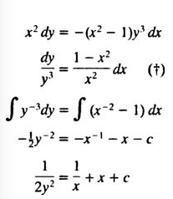

2.
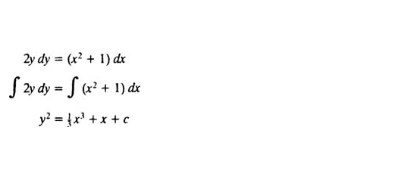

Using Geogebra to solve Differential Equations:

Step 1. Slope fields and solving differential equations
To plot a slope field use SlopeField[f] in the
Algebra View, e.g.
- f(x,y)= 2x^2
- SlopeField[f]

Step 2. To find a particular solution use SolveODE[f,A]
in the Algebra View, e.g.
- A=(1,3)
- SolveODE[f,A]
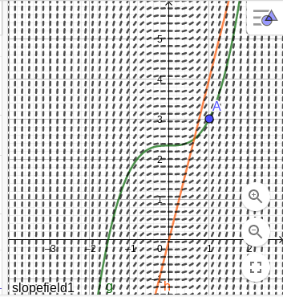

Step 3. To find a general solution use
SolveODE[equation] in the CAS View, e.g.
- SolveODE[y’=2x^2]
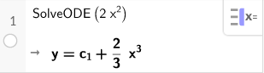
Step 4. Second Order Differential Equations:
Using the CAS toolbox input:
SolveODE[ <Equation>, <Point(s) on f>, <Point(s) on f'> ]
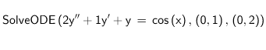
Use this command in Geogebra to solve for Second order differential equation

References:
- “Further Pure Mathematics with Technology.” MEI, mei.org.uk/fpt.
- Differential Equations - Definitions, tutorial.math.lamar.edu/Classes/DE/Definitions.aspx.
- Separable Equations, www.cliffsnotes.com/study-guides/differential-equations/first-order-equations/separable-equations.

